Contents

Overview 3

Problem 3

Objective 3

Approach 3

Data Processing and Data Loading 5

Model Development 10

Scratch Model 10

Baseline Model (Test Model 1) 10

Test Model 2 11

Test Model 3 13

Test Model 4 14

Test Model 5 15

Test Model 6 16

Test Model 7 17

Test Model 8 18

Pre-trained Model 20

Baseline Mode (Test Model 1) 20

Test Model 2 22

Test Model 3 23

Test Model 4 25

Test Model 5 26

Test Model 6 27

Test Model 7 28

Test Model 8 29

Test Model 9 30

Test Model 9.5 31

Test Model 10 32

Model Evaluation 34

Scratch Models 34

Pre-Trained Models 37

Summary 40

Best Model Testing 43

Beignets 44

Breakfast Burritos 45

Clam Chowder 46

Crème Brulee 47

Croque Madame 48

Cupcakes 49

French Onion Soup 50

Hummus 51

Pad Thai 52

Shrimp and Grits 53

Summary 54

Further Improvements 54

References 55

# Overview

## Problem

The classification of food images is a significant challenge within the domain of computer vision and deep learning. This is driven by the growing demand for automation and precision in food-related industries such as health, nutrition, retail, and hospitality. The ability to accurately classify food or food images can enable applications like calorie estimations, dietary tracking, automated menu recommendations, and even food waste management.

Food image classification is a complex task due to high intra-class variance, inter-class similarity, and dataset size and diversity. Images within a single food category can vary greatly depending on lighting and presentation. There might also be similarities between different food types such as pasta and noodles or soups and stews. Large datasets such as this one, Food-101, contain diverse images that require preprocessing and effective modelling to achieve successful classification.

## Objective

The goal of this assignment is to develop a deep learning-based classification model that is capable of recognising and classifying images of 10 distinct food types. In this case, the assigned food types are beignets, breakfast burrito, clam chowder, crème brulee, croque madame, cupcakes, French onion soup, hummus, pad thai, shrimp and grits. The purpose of the task is to leverage the dataset provided and utilise deep learning algorithms and techniques to build and evaluate the models for optimal performance.

Some challenges to address are data complexity, performance evaluation, and practical application. The dataset contains high-resolution images which can result in computational overhead or longer training times. Therefore, efficient data preprocessing, resizing, and augmentation are critical to manage computational load without sacrificing performance. Models built must be rigorously evaluated on a test set to measure the real-world applicability of the model. Thus, a detailed comparison of the model’s accuracy and loss during the testing phase is necessary to identify the best-performing model. After identifying the best model, real-world food images are to be downloaded from the internet to continue with further testing of its reliability outside the curated dataset.

## Approach

The approach towards this problem is crucial in ensuring seamless processing and efficient model building and evaluation.

Data is loaded and processed to ensure that there is data for the model to train, validate and test on.

Different models are created to explore the different combinations of parameters or possible pre-trained models that can be utilised. A baseline model is created first then further improved on. For models created from scratch, a convolutional neural network architecture is created using Conv2D and Dense Layers. The model is then incrementally increased in complexity such as adding more layers, changing number of nodes, and using different optimisers. This is to optimise the performance of the model while avoiding overfitting. As for the models that leverages pre-trained models, different types of pre-trained models are used with methods such as freezing layers, and unfreezing last layer be attempted to fine tune the model.

The model is then evaluated using the test data subset, using metrics such as accuracy and loss. The performance of the models are then compared to determine to best possible model. The results of each model are visualized using training and validation curves after each model training to show how the models improved over epochs. This is also to identify the smallest number of epochs to achieve the best possible performance.

The best model is then deployed and tested on real-world food images from the internet. Its performance is also analysed on unseen data to discuss its reliability and accuracy in predicting the 10 food classes provided.

# Data Processing and Data Loading

Firstly, before creating the convolutional neural network models, the downloaded dataset must be processed and loaded. Using the Image_Processing notebook provided, the specific directories for train, validate and test images are created.

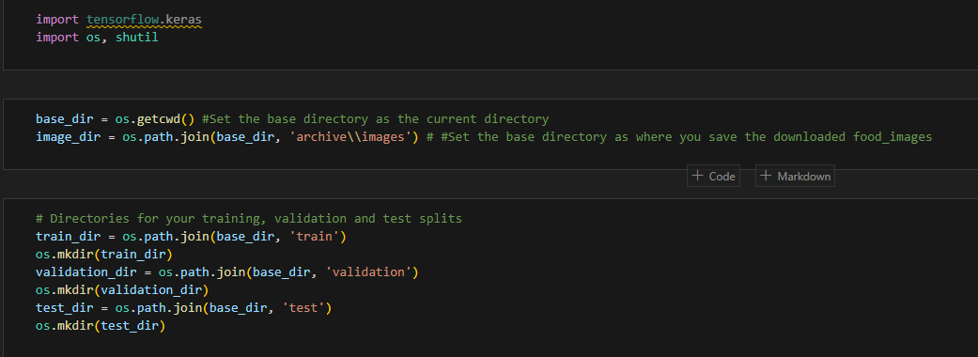

The data is specified by the Food_list file where we have to enter the specific text file to gather the required data. In this case, the index was 49. In this file, it has the necessary names of the food types, which are beignets, breakfast burrito, clam chowder, crème brulee, croque madame, cupcakes, French onion soup, hummus, pad thai, shrimp and grits. These names are matched to the downloaded data files to extract the images of each specified food type and appended into a list.

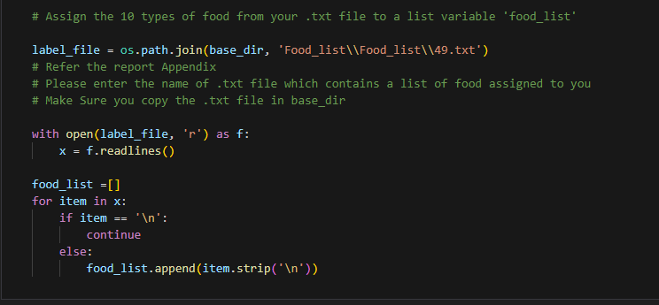

The first 750 images in each food type are added into the train folder and the next 200 images to added into the validation folder, with the remaining 50 images being moved into the test folder. This ultimately creates the dataset that can be used during modelling to train and validate the models created. The ratio of train data to validation data to test data for all food types to be predicted is 7,500 to 2,500 to 500, totalling to 10,000 images across the 10 different classes.

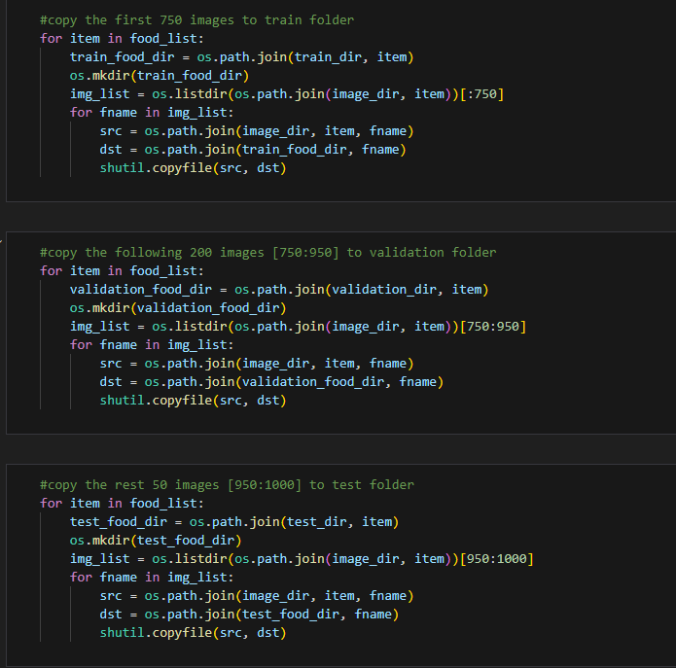

After processing the data from the dataset, the relevant libraries were imported and the relevant directories were specified.

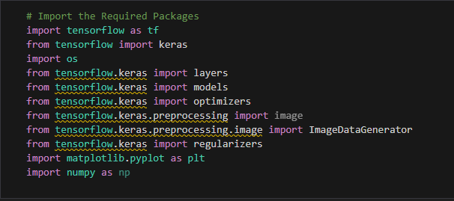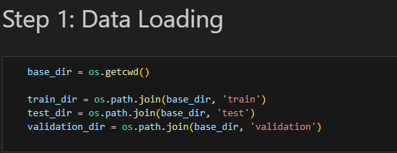

The data is then loaded into train and validation data generators for modelling. Each image data generator are set at a rescale value of 1./255. The image size used for all data is a **consistent 150 by 150**, with a **batch size of 20** and a **categorical class mode** since there is 10 classes to predict from. As shown, the data batch shape of the train generator is (20, 150, 150, 3). As for the label’s batch of the train generator is (20,10) since there are 10 different classes.

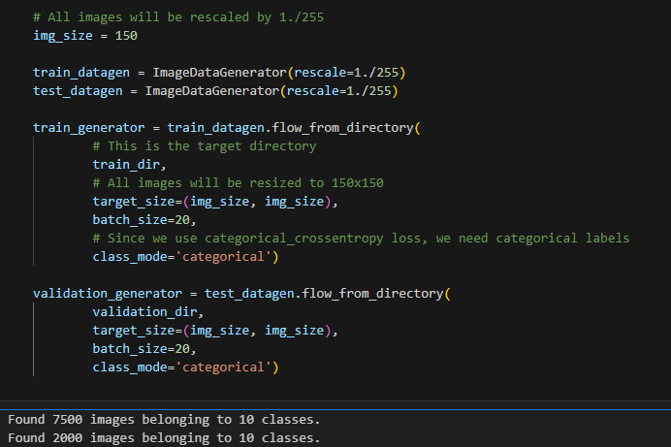

As for other cases such as the data augmentation, the data is transformed and rescaled to extract the features of the data. The code below uses TensorFlow's ImageDataGenerator for real-time data augmentation. It applies transformations like scaling, rotation, shifting, shearing, zooming, and flipping to training images. These augmentations increase dataset diversity, prevent overfitting, and improve model generalization by exposing the model to varied versions of the data during training.

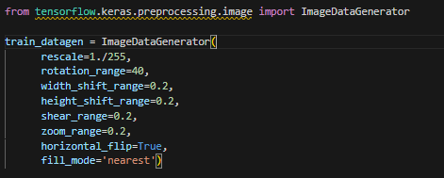

Some transformation methods are rescaling of the image, rotations and flipping of the images, with the goal of preventing overfitting. Then, similar to without data augmentation, the train generator and the validation generator were created. These are the data used to evaluate and train the model.

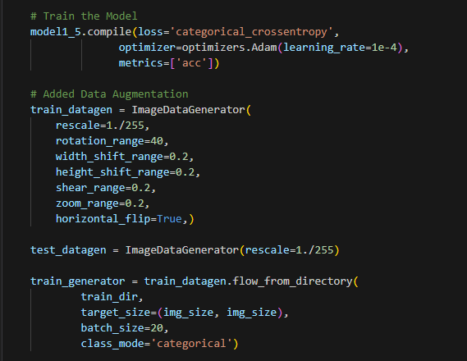

# Model Development

There are 2 sections to the model creation and development. A section shows the models created from scratch, while another section shows the creation of models using pre-trained models or in this case transfer learning. Each section has a baseline model that is used as a base to further improve on. Multiple models are created to explore the different possibilities and compared to the previous models created.

## Scratch Model

Firstly, the first section shows the models created from scratch without any pre-trained models.

### Baseline Model (Test Model 1)

The first section baseline model is as shown:

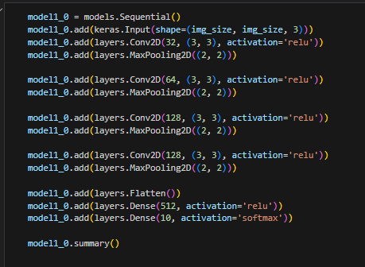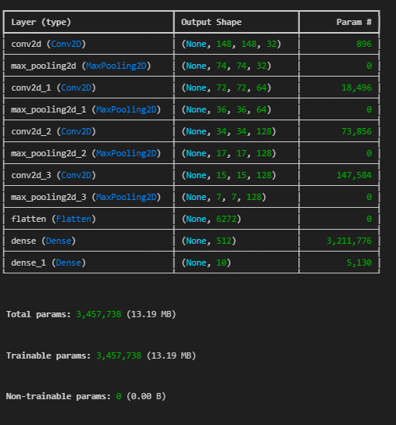

The first model consists of 4 Conv2D layers that are followed by a 2 by 2 Max Pooling Layer. The nodes in the Conv2D layers are 32, 64, 128, and 128 respectively. They are then flattened and fitted with a Dense layer of 512 nodes. All Conv2D and Dense layers have the activation function of ReLU. The last Dense layer has 10 nodes with the activation function of Sigmoid as it is the output layer where it predicts one of the 10 classes specified. The model is trained using the RMSprop optimiser with a learning rate of 1e-4 and 30 epochs. After training, the training loss and validation loss are visualised to learn how the model is trained and what is the best possible epoch to stop training to achieve the best possible accuracy on the model. The charts are as shown below:

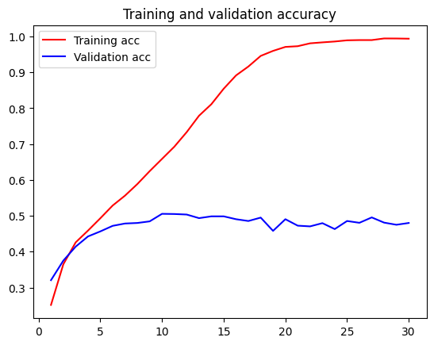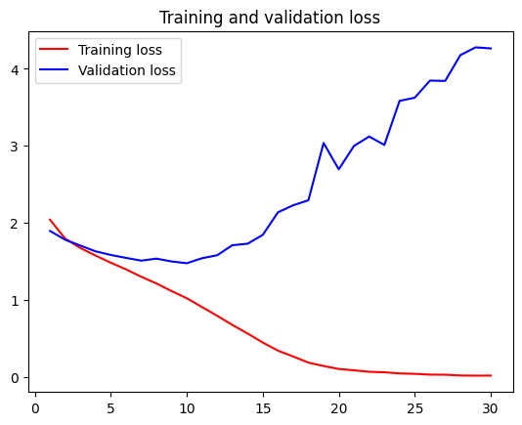

The validation accuracy started to flatline at 10 epochs, thus resulting in overfitting. As for the loss graph, the validation loss begins to kick up after 10 epochs. The model is retrained to 10 epochs with the charts shown:

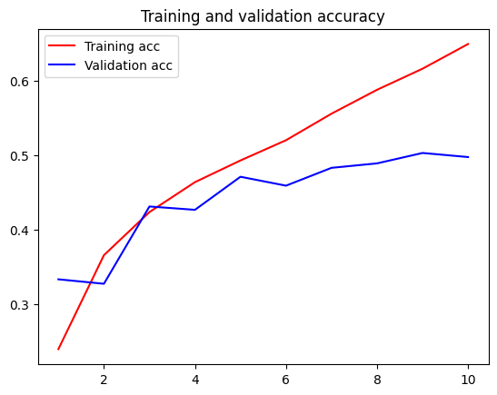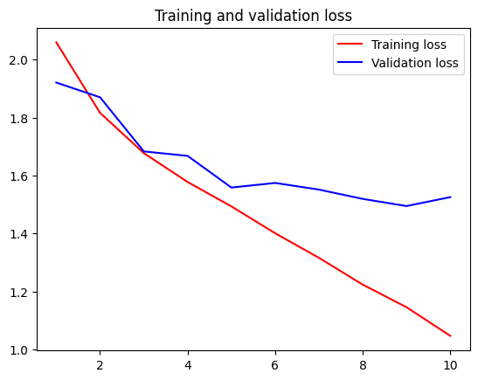

The validation accuracy and loss reached was 0.4975 and 1.5253 respectively.

### Test Model 2

The subsequent models created are improvements of the previous and baseline model. However, this does not guarantee better accuracy and loss.

Compared to the baseline model, fewer nodes are used for each of the Conv2D layers. This is conducted as models with fewer nodes tend to emphasise key patterns in the data, indirectly promoting the selection of important features. The model parameters are as shown below:

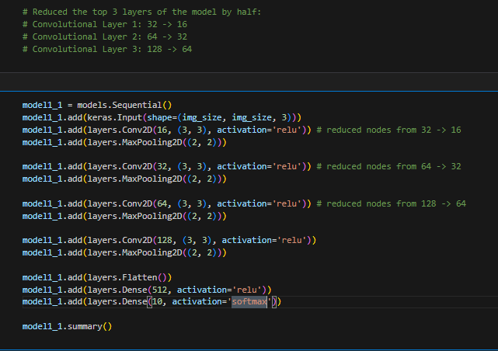

After training, the charts are as shown below:

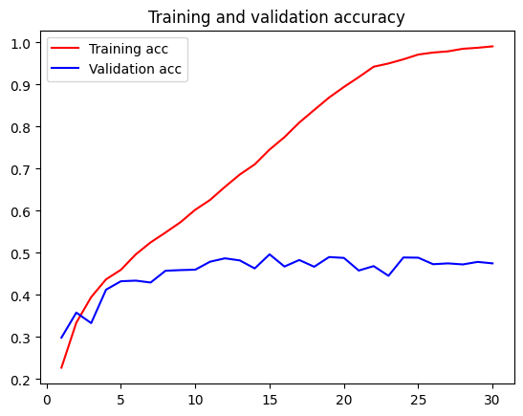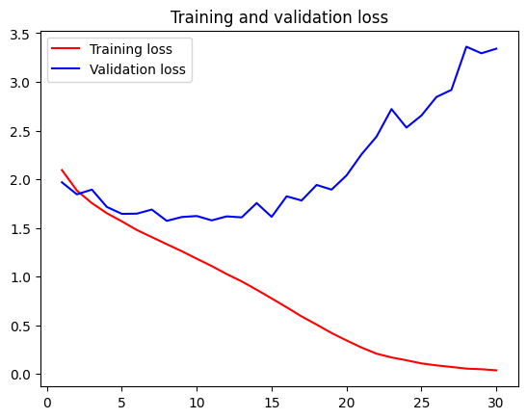

As shown, the validation accuracy started to flatline at 11 epochs after increasing. This results in overfitting. As for the loss graph, the validation loss started to kick up after 11 epochs.

The model is retrained to 11 epochs with the charts shown:

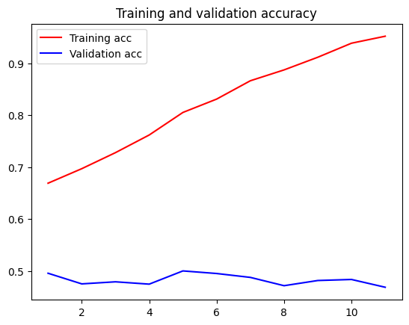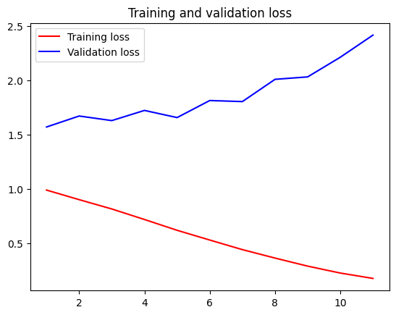

The validation accuracy and loss reached was 0.4685 and 2.4170 respectively. This showed no improvements in the scores.

### Test Model 3

Compared to the previous model, an additional Conv2D layer and 2 by 2 Max Pooling Layer are added. The model parameters are as shown:

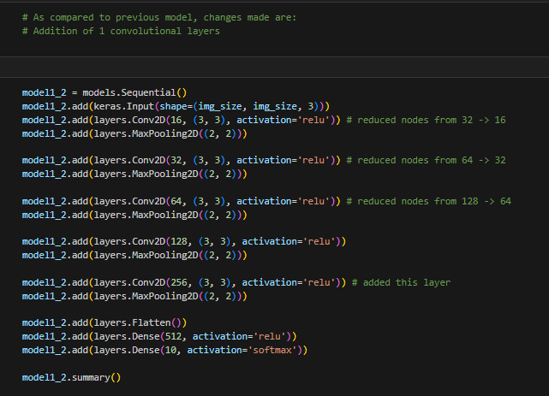

After training, the charts are as shown below:

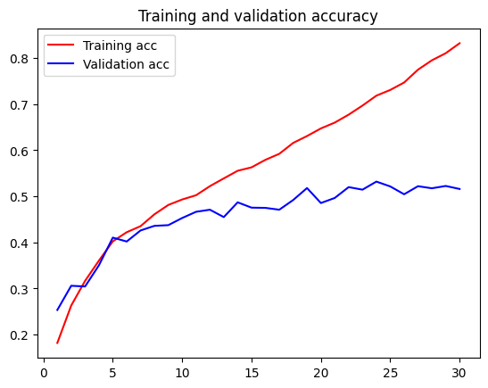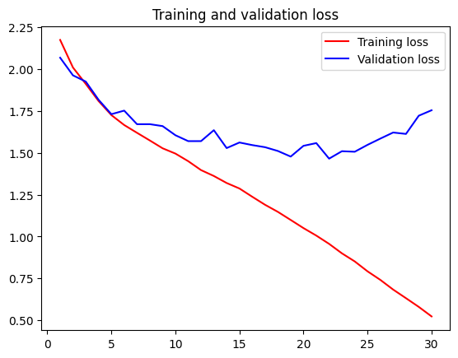

As shown, the validation accuracy started to flatline at 22 epochs after increasing. This shows signs of overfitting. As for the loss graph, the validation loss started to kick up at 22 epochs. The model is retrained to 22 epochs with the charts shown:



The validation accuracy and loss reached was 0.5310 and 1.4717 respectively. This showed improvements in the scores.

### Test Model 4

Compared to the previous model, L2 regularizers are added to the last Conv2D layer and in the dense layer. Regularizers add a penalty term to the loss function, discouraging the model from fitting noise or overly complex patterns in the training data. This prevents the model from memorising the data and helps it generalise better to unseen data.

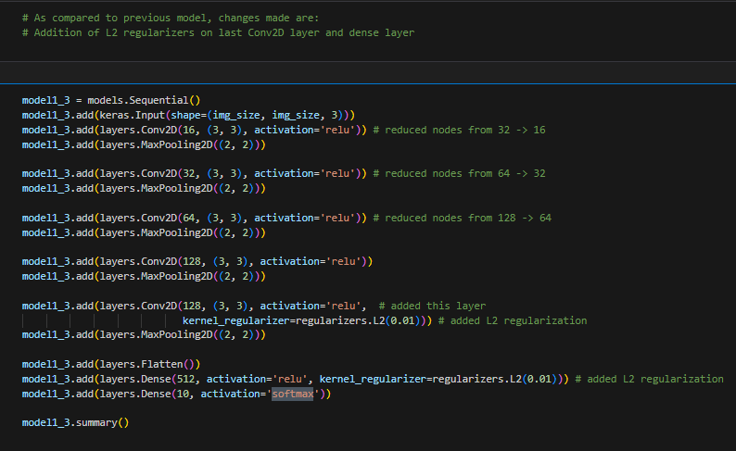

After training, the charts are as shown below:

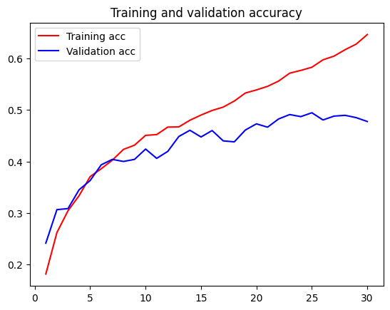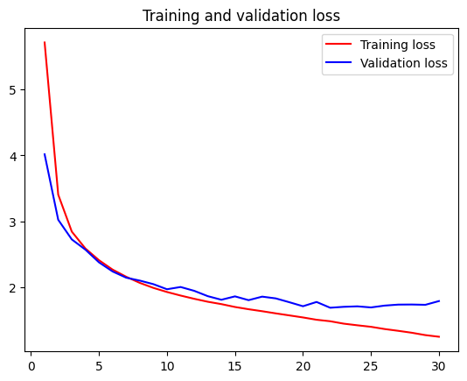

As shown, the validation accuracy started to flatline at 30 epochs after increasing. This shows signs of overfitting. As for the loss graph, the validation loss started to flatline at 30 epochs. This is the best accuracy and loss for the model.

The validation accuracy and loss reached was 0.4775 and 1.7914 respectively. This showed no improvements in the scores.

### Test Model 5

Compared to the previous model, the fifth model has a different optimiser. The optmiser used in this case is the Adam optimiser. Adam automatically adjusts the learning rate for each parameter based on the gradients' magnitude.

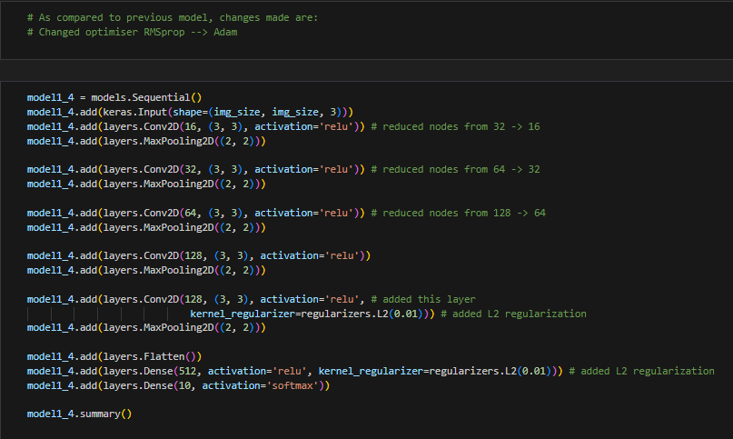

After training, the charts are as shown below:

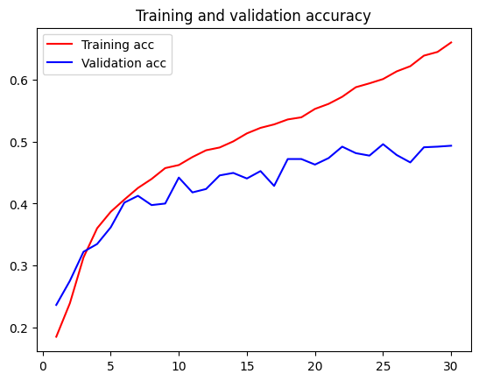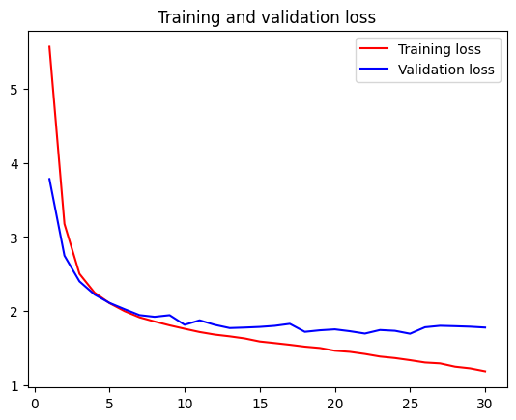

As shown, the validation accuracy and loss started to flatline at 30 epochs. This shows signs of overfitting. The validation accuracy and loss reached was 0.4935 and 1.7773 respectively. This showed no improvements in the scores.

### Test Model 6

Compared to the previous model, data augmentation is used and the regularizers are removed. Data augmentation allows us to artificially increase the size and diversity of a dataset by creating modified versions of the existing data.

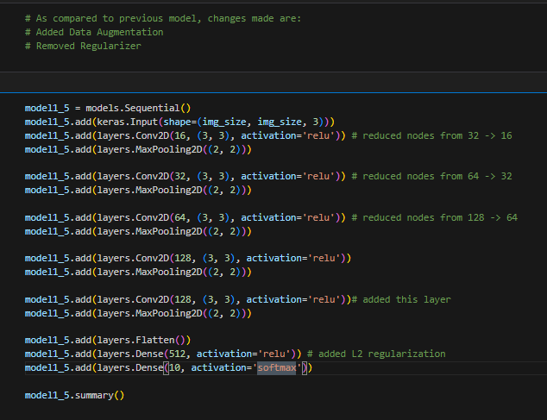

After training, the charts are as shown below:

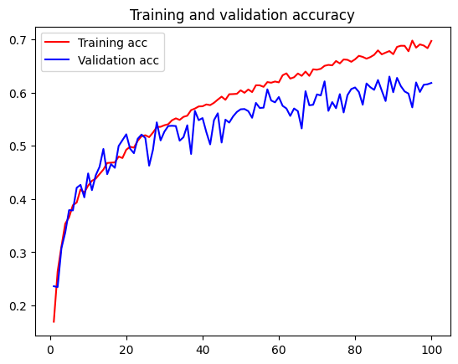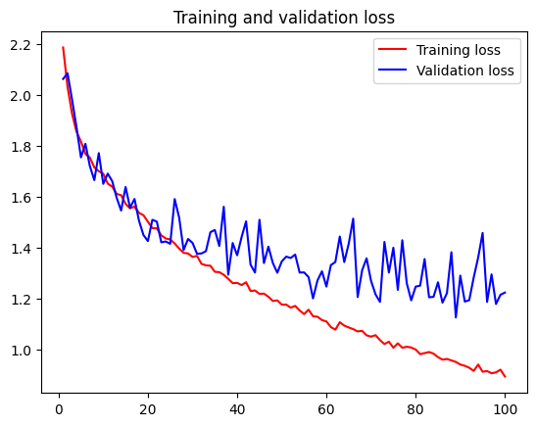

At 100 epochs, the validation accuracy and the loss begin to flatline.

The validation accuracy and loss reached was 0.6180 and 1.2231 respectively. This showed improvements in the scores.

### Test Model 7

Compared to the previous model, the number of nodes for each layer were increased. This is to increase the model capacity to represent complex relationships and patterns.

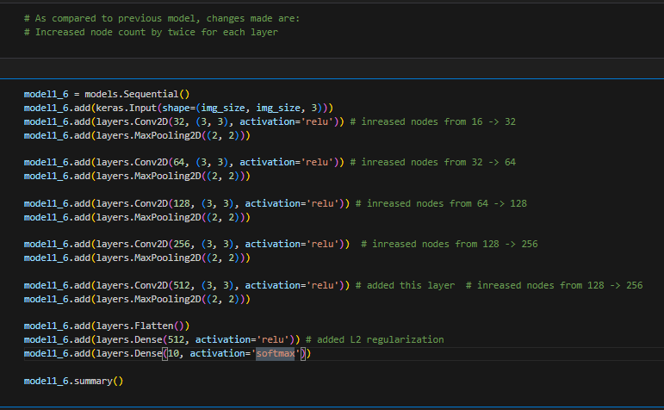

After training, the charts are as shown below:

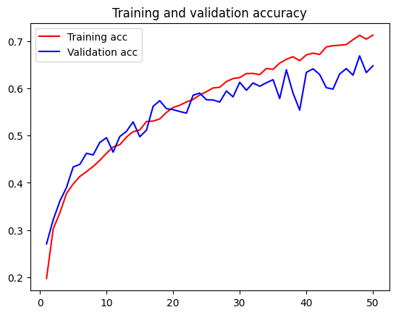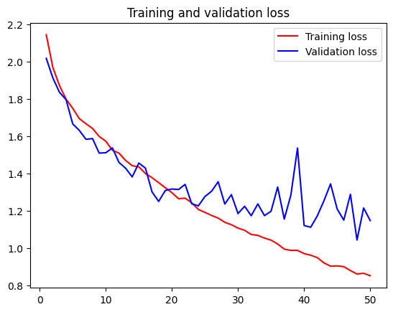

At 50 epochs, the validation accuracy and the loss begin to flatline.

The validation accuracy and loss reached was 0.6480 and 1.1484 respectively. This showed slight improvements in the scores.

### Test Model 8

Compared to the previous model, dropout layers and L2 regularizer are added. Nodes are also decreased with the use of the Adam optimiser. This is to utilise the different parameters that were used across the other models.

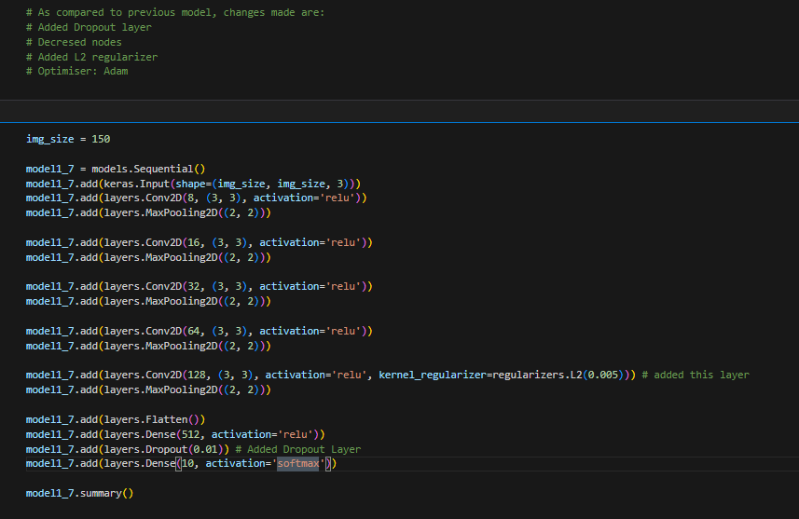

After training, the charts are as shown below:

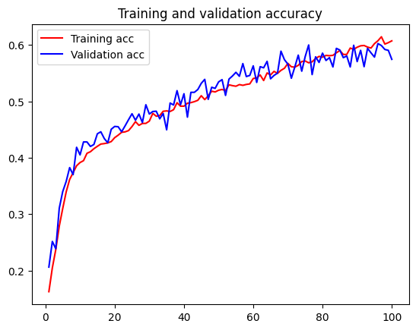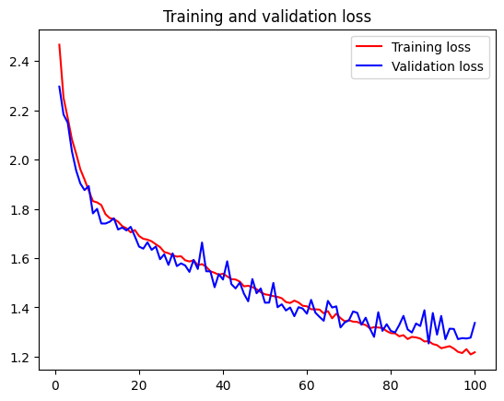

At 100 epochs, the validation accuracy and the loss are still sticking close to the train accuracy and loss. The model is retrained to 150 epochs to determine the best score.

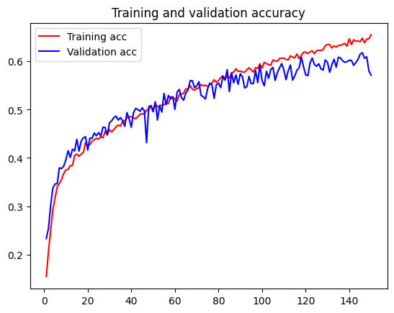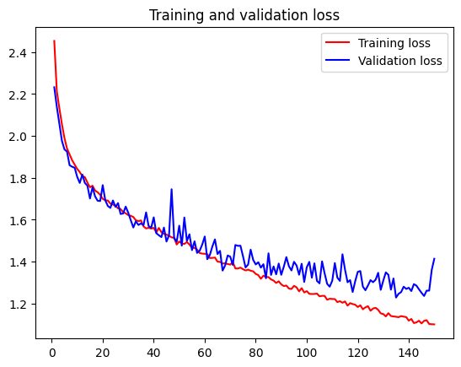

The validation accuracy and loss reached was 0.5715 and 1.4138 respectively. This showed no improvements in the scores.

## Pre-trained Model

Secondly, this section shows the models created pre-trained models with fine tuning. The weights used for all models are Imagenet with an image size of 150.

### Baseline Mode (Test Model 1)

The pre-trained convolutional neural network, VGG16, without any changes is used as the baseline model.

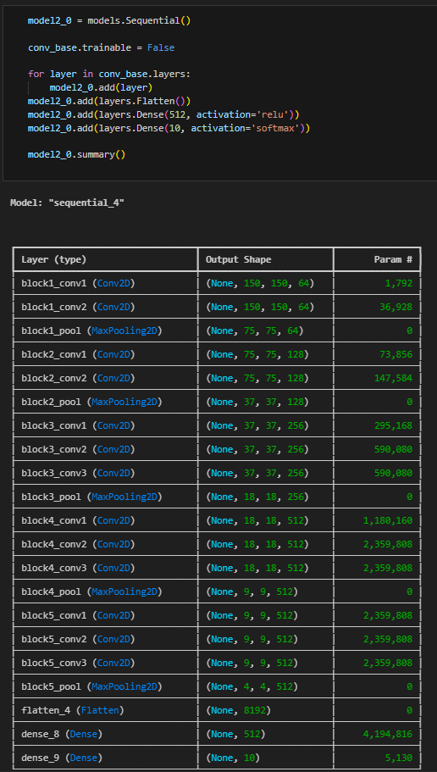

The first model has an added Dense layer with 512 nodes. It has the activation function of ReLU. The output layer is a Dense layer with 10 nodes due to the number of classes to predict, with the Softmax activation function. The model is not trainable as it is set a base model. The model is trained with RMSprop optimser at the learning rate of 2e-5. This model is trained to 30 epochs to determine the best timing to stop the learning.

After training, the charts are as shown:

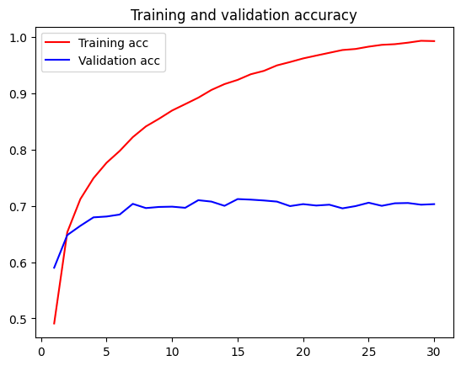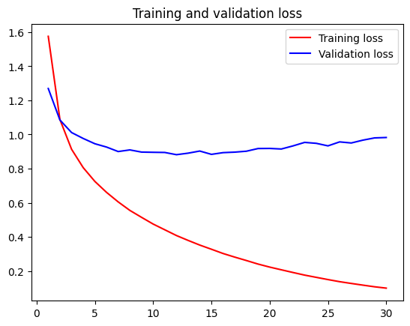

At 15 epochs, the validation accuracy and the loss begin to flatline. The model is retrained to 15 epochs to achieve the best scores.

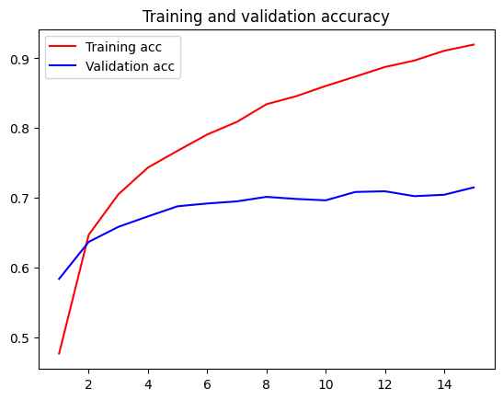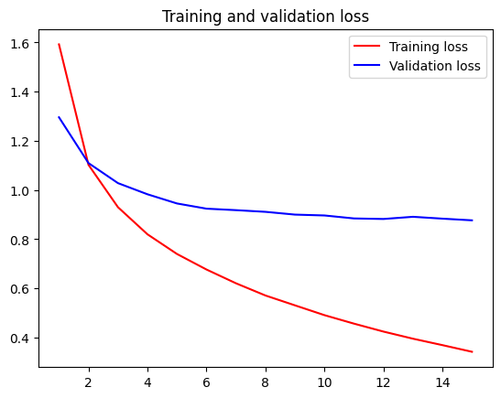

The validation accuracy and loss reached was 0.7150 and 0.8769 respectively. This is significantly better than the scratch models.

### Test Model 2

Compared to the previous model, data augmentation was attempted to check for improvements. VGG16 is the same convolutional base model used.

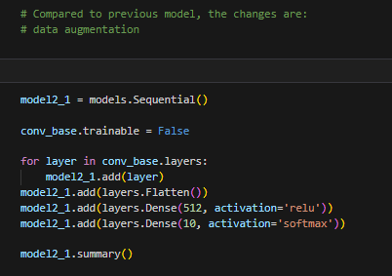

After training, the charts are as shown:

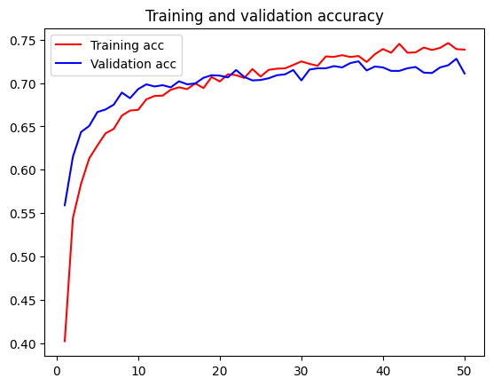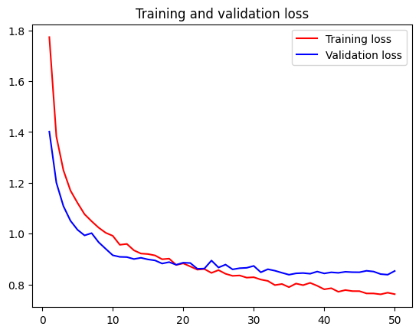

After 50 epochs, the training and validation accuracies and losses are still increasing.

The validation accuracy and loss reached was 0.7110 and 0.8533 respectively. The accuracy score did not improve but the loss did.

### Test Model 3

Compared to the previous model, the last layer is unfroze to train it. Data augmentation is also used. VGG16 is the same convolutional base model used. Unfreezing allows the model to adapt its high-level features to the image classification task.

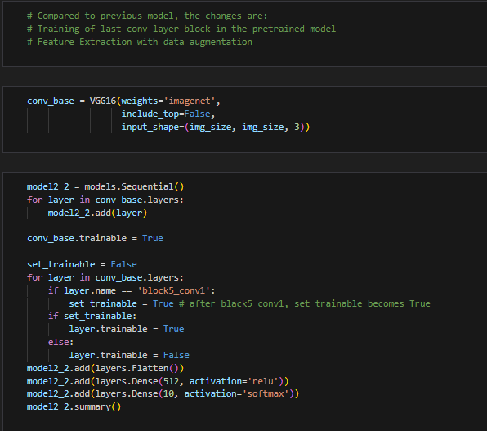

After training, the charts are as shown:

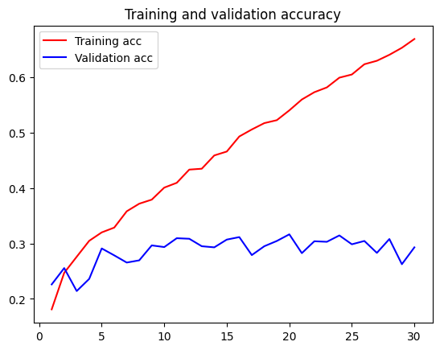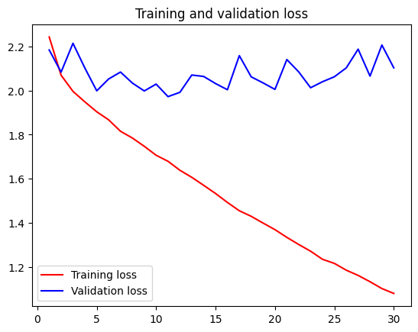

After 20 epochs, the validation accuracy starts to flatline while the loss starts to kick up. The model is retrained to 20 epochs since this provides the best score.

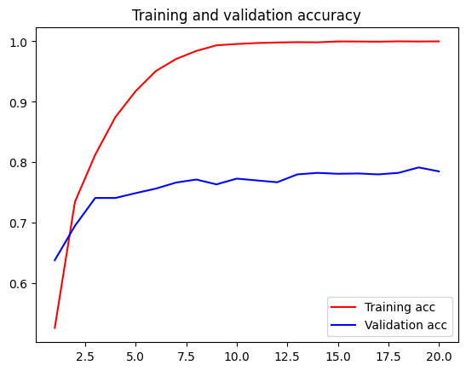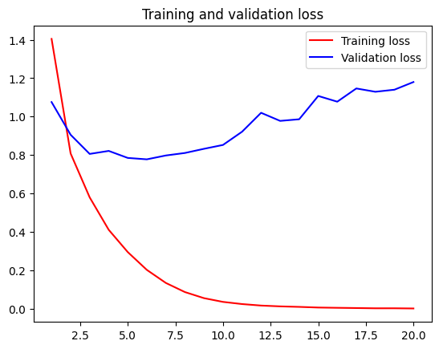

The validation accuracy and loss reached was 0.7850 and 1.1801 respectively. The accuracy score improved but the loss did not.

### Test Model 4

Compared to the previous model, convolutional base model is changed to VGG19, which is a similar but improved model than the VGG16. The parameters are like that of the baseline model but with a different convolutional base.

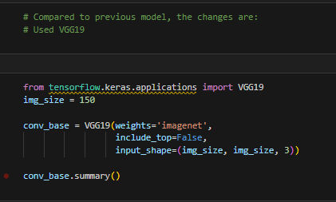 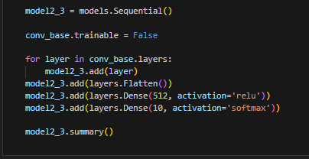

After training, the charts are as shown:

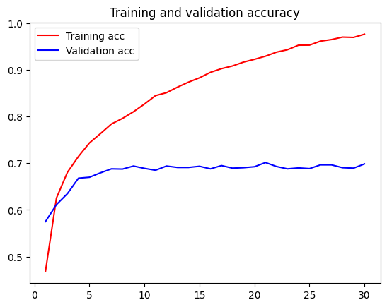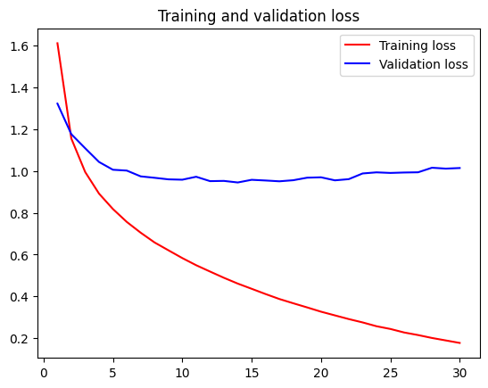

After 30 epochs, the validation accuracy starts to flatline while the loss starts to kick up. This is ideal timing although the accuracy score is overfitting before loss starts increasing.

The validation accuracy and loss reached was 0.6985 and 1.0143 respectively. The scores did not improve at all.

### Test Model 5

Compared to the previous model, data augmentation is used along with the VGG19 convolutional base model.

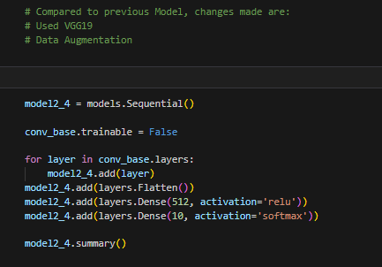

After training, the charts are as shown:

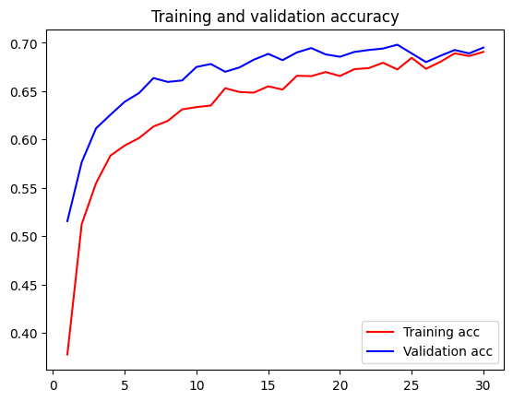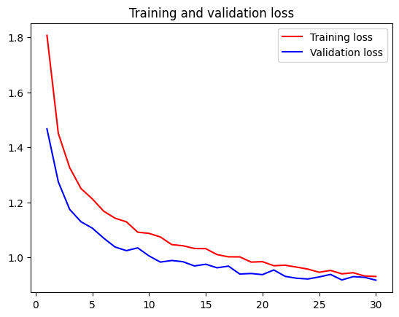

After 30 epochs, the validation accuracy and loss start to flatline. They also converge at 30 epochs, showing a decent score.

The validation accuracy and loss reached was 0.6950 and 0.9173 respectively. The scores did not improve at all although the loss is smaller.

### Test Model 6

Compared to the previous model, the last layer is unfrozen and data augmentation is applied along with the convolutional base, VGG19.

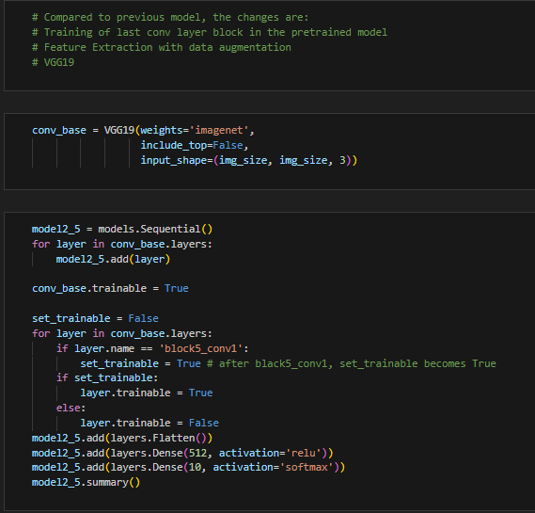

After training, the charts are as shown:

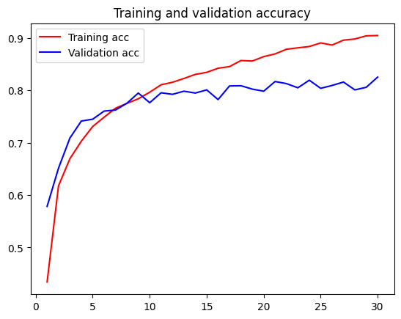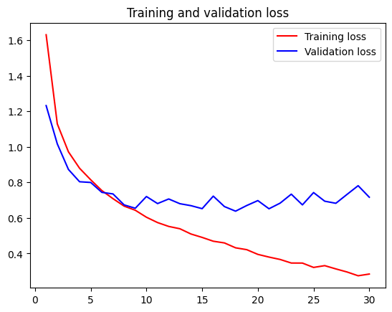

After 30 epochs, the validation accuracy and loss start to flatline. This is ideal timing although the accuracy score is overfitting before loss starts increasing.

The validation accuracy and loss reached was 0.8255 and 0.7167 respectively. The scores improved significantly.

### Test Model 7

Compared to the previous model, the InceptionV3 convolutional base model is used. Similarly, for subsequent models, the models are similar to the baseline model with just the convolutional base model being altered.

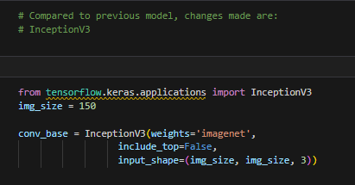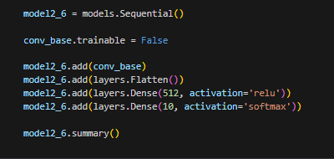

After training, the charts are as shown:

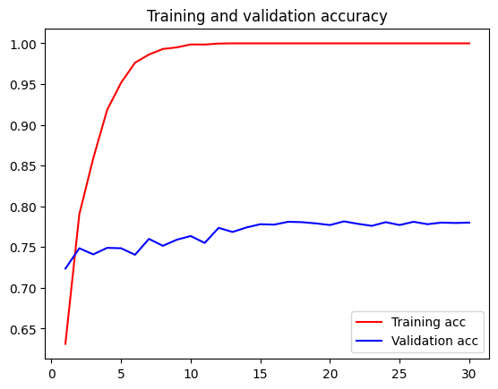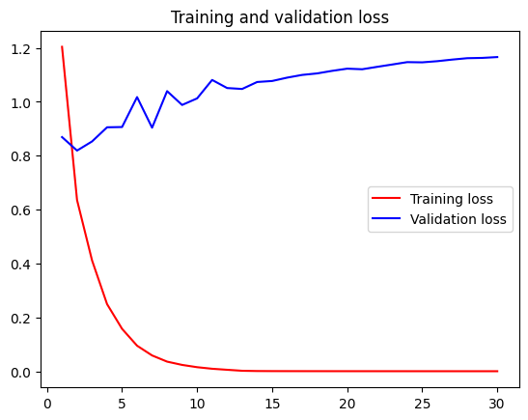

After 17 epochs, the validation accuracy and loss start to flatline. The model is retrained at 17 epochs to achieve the best possible score.

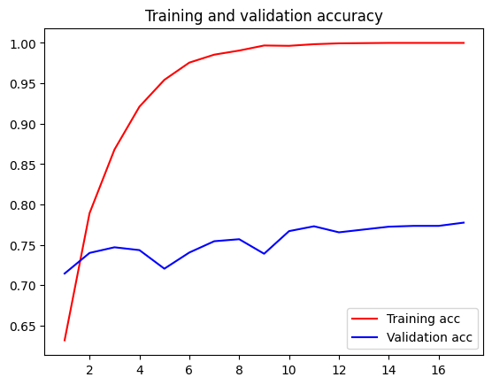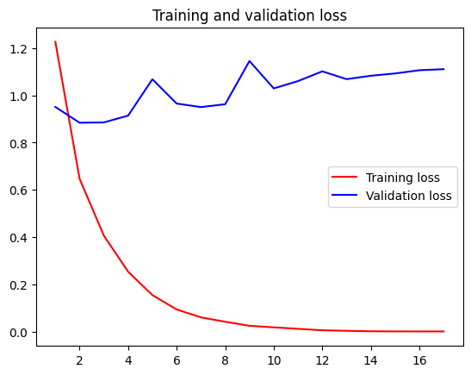

The validation accuracy and loss reached was 0.7775 and 1.1109 respectively. The score did not improve at all.

### Test Model 8

Compared to the previous model, the Xception convolutional base model is used instead.

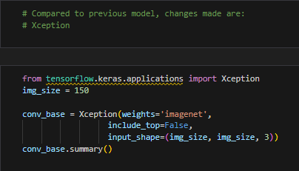 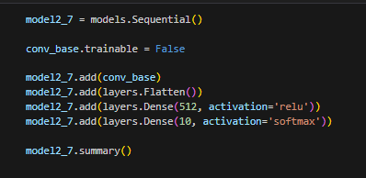

After training, the charts are as shown:

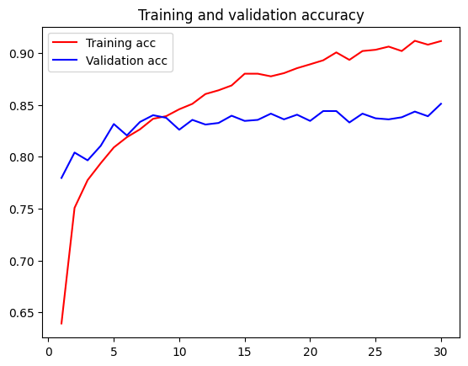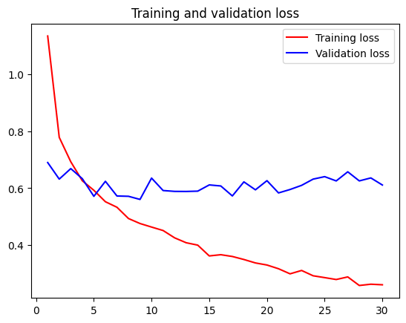

After 9 epochs, the validation accuracy and loss start to flatline. The model is retrained to 9 epochs to achieve the best possible score before the loss kicks up.

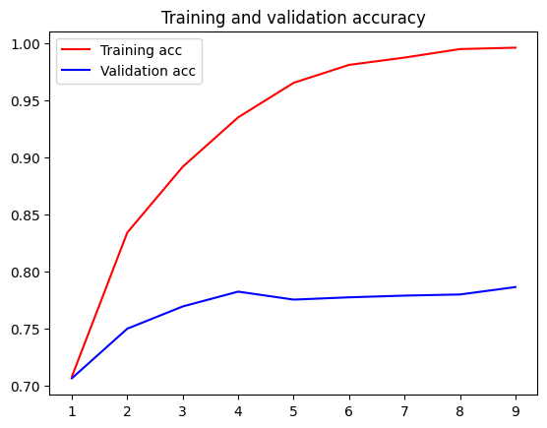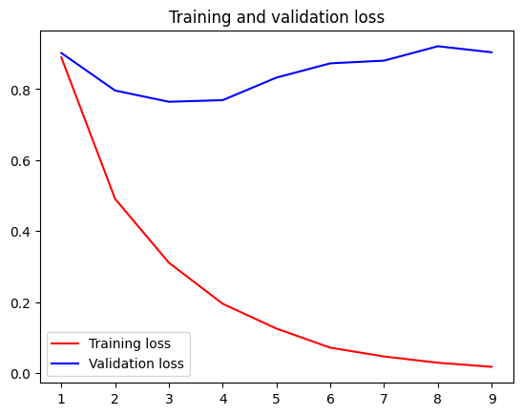

The validation accuracy and loss reached was 0.7865 and 0.9036 respectively. The score improved slightly.

### Test Model 9

Compared to the previous model, the DenseNet169 convolutional base model is used.

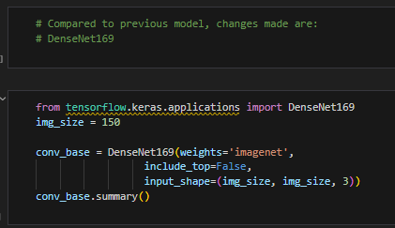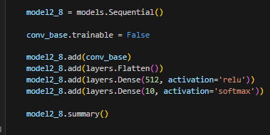

After training, the charts are as shown:

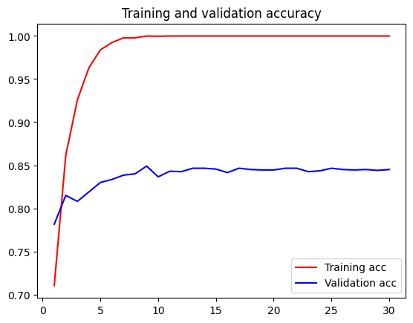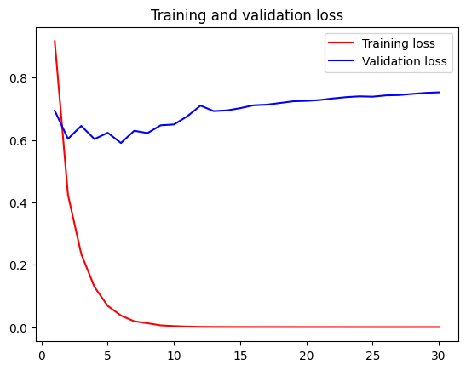

After 9 epochs, the validation accuracy and loss start to flatline. The model is retrained to 9 epochs to achieve the best possible score.

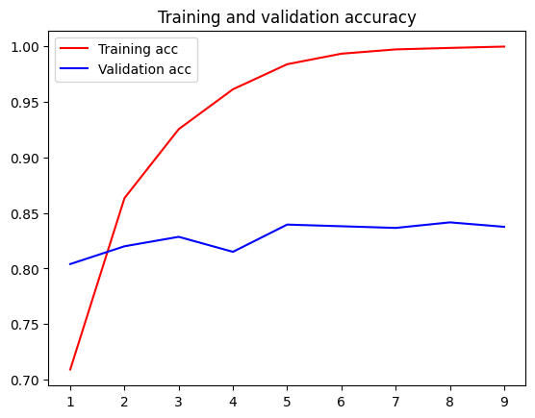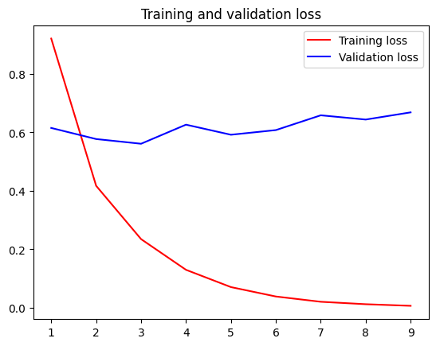

The validation accuracy and loss reached was 0.8375 and 0.6686 respectively. The score improved significantly.

### Test Model 9.5

This model is created as a sub-model using the previous model since it performed well. Data augmentation is used.

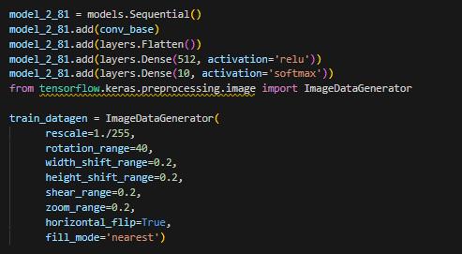

After training, the charts are as shown:

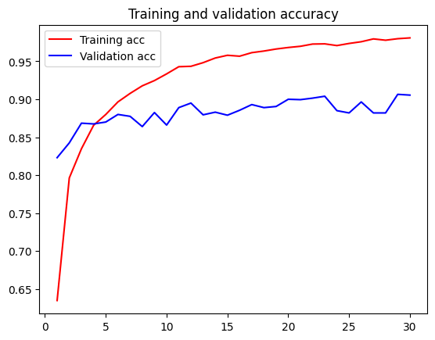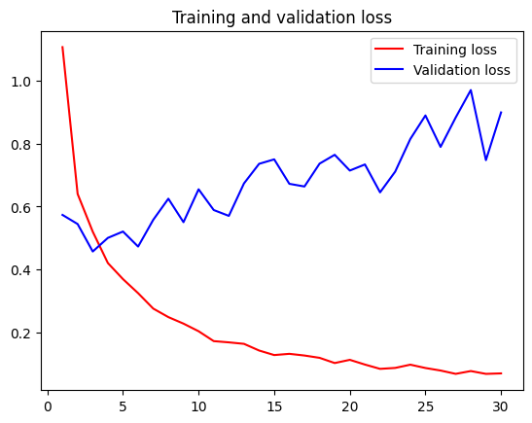

After 10 epochs, the validation accuracy start to flatline and loss starts increasing. The model is retrained to 10 epochs to achieve the best possible score.

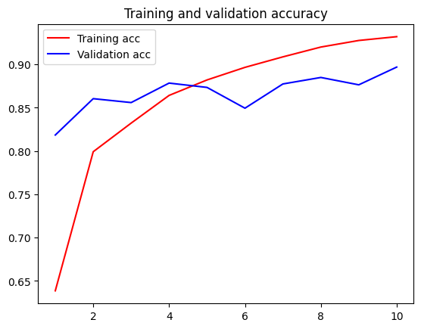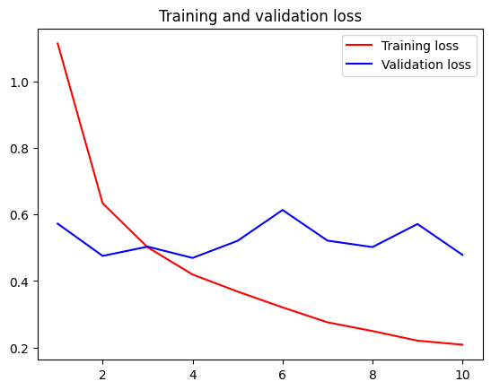

The validation accuracy and loss reached was 0.8970 and 0.4787 respectively. The score improved slightly.

### Test Model 10

For the last model, compared to the previous model, the MobileNetV2 convolutional base model is used.

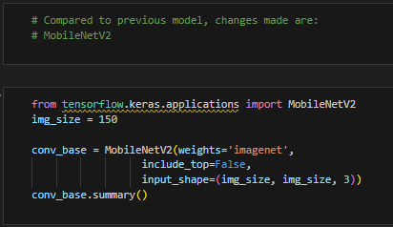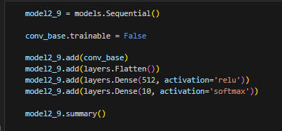

After training, the charts are as shown:

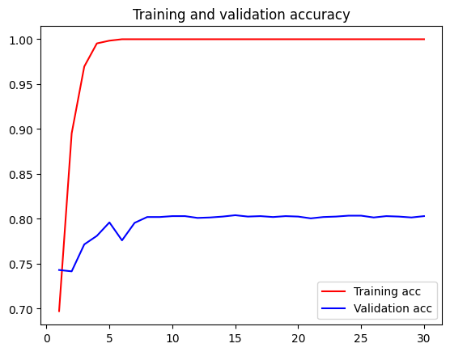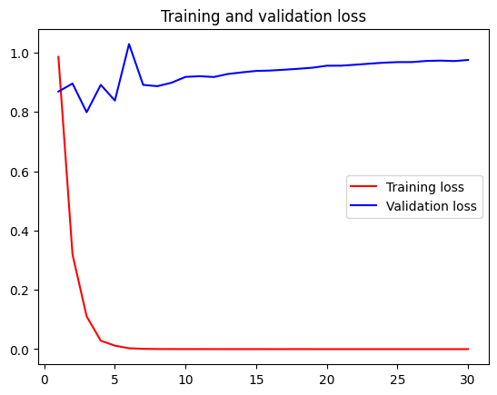

After 8 epochs, the validation accuracy and loss start to flatline. The model is retrained to 8 epochs to achieve the best possible score.

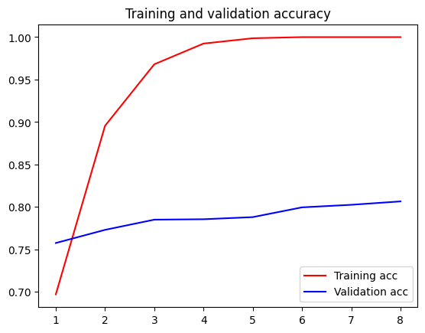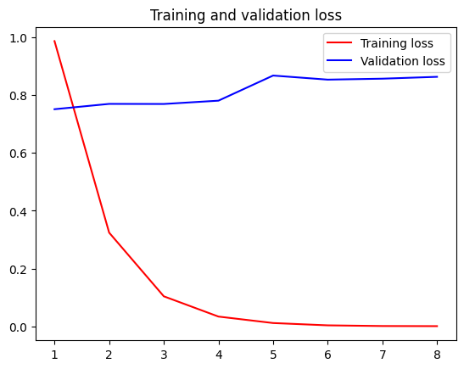

The validation accuracy and loss reached was 0.8065 and 0.8637 respectively. The score did not improved.

After the creation and development of the models, the models are saved as their respective files based on the model names to be called for evaluation.

# Model Evaluation

In this section, the models are evaluated on their performance on the test set of data, which contains images of all 10 food types. The test data is called as shown:

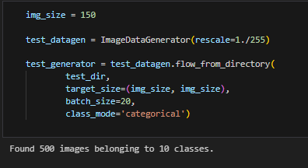

The images in the test data generator is rescaled to 1./255. The image size is set to 150 with a batch size of 20 and a categorical class mode due to 10 different classes.

Each model is then called into a variable of their own and evaluated using the test data generator. The metrics used are accuracy and loss.

## Scratch Models

**Model 1.0 (Base Model)**

This model is the baseline model that is created first in the scratch model section. For the model, the scores are as shown:

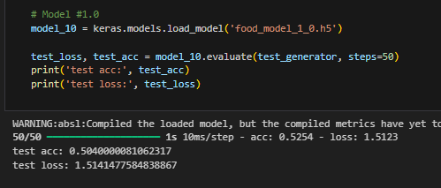

**Model 1.1**

For this model, the scores are as shown:

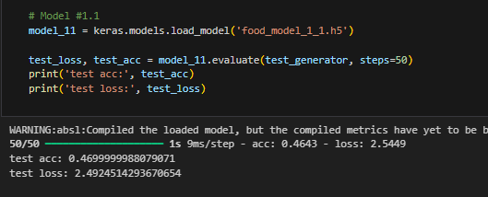

**Model 1.2**

For this model, the scores are as shown:

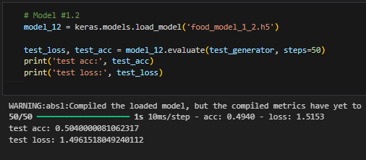

**Model 1.3**

For this model, the model scores as shown:

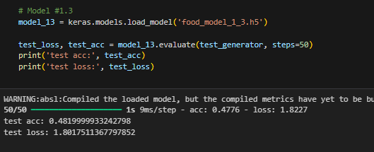

**Model 1.4**

For this model, the model scores as shown:

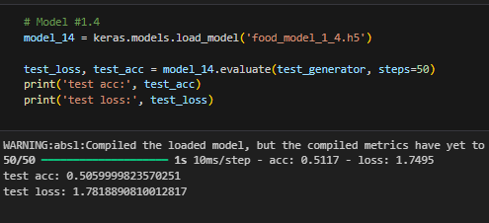

**Model 1.5**

For this model, the model scores as shown:

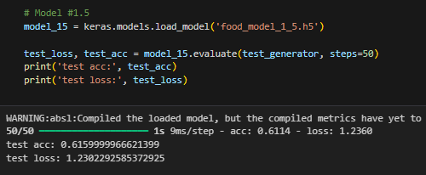

**Model 1.6**

For this model, the model scores as shown:

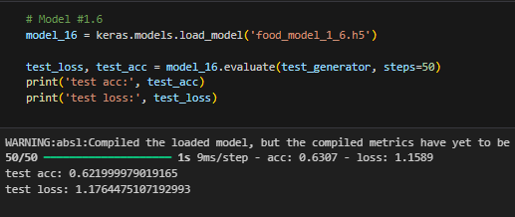

**Model 1.7**

For this model, the model scores as shown:

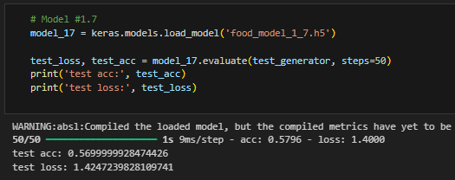

## Pre-Trained Models

**Model 2.0 (Base Model)**

This model is the baseline model that is created first in the pre-trained section. For this model, the model scores as shown:

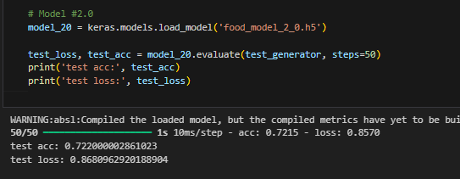

**Model 2.1**

For this model, the model scores as shown:

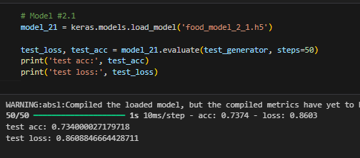

**Model 2.2**

For this model, the model scores as shown:

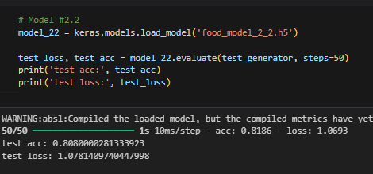

**Model 2.3**

For this model, the model scores as shown:

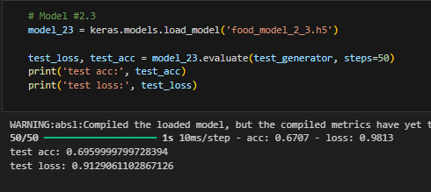

**Model 2.4**

For this model, the model scores as shown:

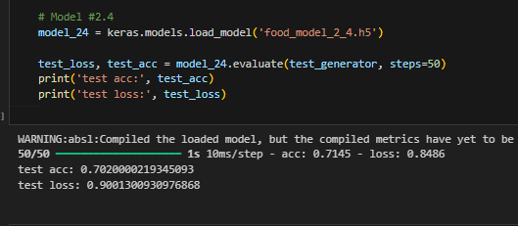

**Model 2.5**

For this model, the model scores as shown:

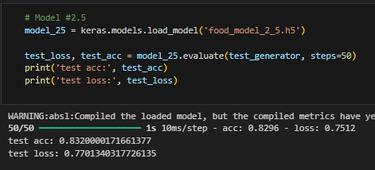

**Model 2.6**

For this model, the model scores as shown:

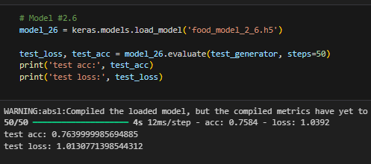

**Model 2.7**

For this model, the model scores as shown:

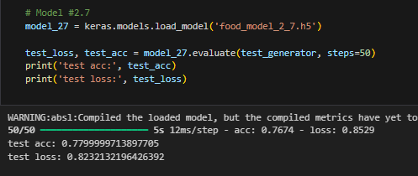

**Model 2.8**

For this model, the model scores as shown:

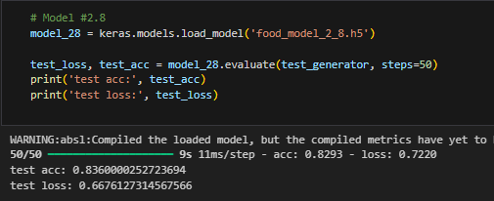

**Model 2.81**

For this model, the model scores as shown:

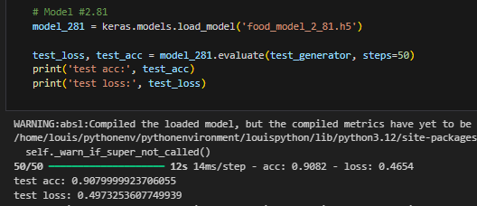

**Model 2.9**

For this model, the model scores as shown:

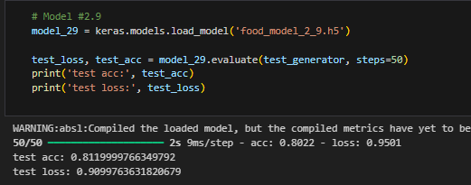

## Summary

**Models created from scratch**

|  |  |  |  |
| --- | --- | --- | --- |
| Model Name/Number | Changes Made | Accuracy (2d.p.) | Loss (2d.p.) |
| Base Model (0) | No changes | 0.50 | 1.51 |
| 1 | Reduced number of nodes by half | 0.46 | 2.49 |
| 2 | Added new Conv2D layer | 0.50 | 1.49 |
| 3 | Added L2 regularizers to last 2 layers | 0.48 | 1.80 |
| 4 | Changed optimiser to Adam | 0.50 | 1.78 |
| 5 | Changed:   * Added data augmentation * Removed regularizer | 0.61 | 1.23 |
| 6 | Increased node count by twice | 0.62 | 1.17 |
| 7 | Changed:   * Added Dropout * Decreased nodes * Added L2 regularizer * Adam Optmiser | 0.56 | 1.42 |

**Models created using pre-trained models**

|  |  |  |  |
| --- | --- | --- | --- |
| Model Name/Number | Changes Made | Accuracy (2d.p.) | Loss (2d.p.) |
| Base Model (0) | VGG16 | 0.72 | 0.86 |
| 1 | VGG16+Data Augmentation | 0.73 | 0.86 |
| 2 | VGG16+Data Augmentation+Unfreeze last layer | 0.80 | 1.07 |
| 3 | VGG19 | 0.69 | 0.91 |
| 4 | VGG19+Data Augmentation | 0.70 | 0.90 |
| 5 | VGG19+Data Augmentation + Unfreeze last layer | 0.83 | 0.77 |
| 6 | InceptionV3 | 0.76 | 1.01 |
| 7 | Xception | 0.77 | 0.82 |
| 8 | DenseNet169 | 0.83 | 0.66 |
| 8.1 | DenseNet169+Data Augmentation | 0.90 | 0.49 |
| 9 | MobileNetV2 | 0.81 | 0.90 |

From both tables which shows the scratch models and pretrained models, it can be seen that the pretrained models perform better than the scratch models due to the overall higher accuracies and lower loss scores. This could be due to the fixed weights in each of the pretrained models.

Generally, models with data augmentation included tend to have a higher score, which is evident by models in the scratch and pretrained tables. They generally have higher accuracies and lower loss scores. Other factors for improving scratch models include increased number of nodes and the removal of regularizers although they reduce noise during training.

As for the pretrained table, the models with the DenseNet169 convolutional base model tends to perform better than the other models, even with fine tuning, ranging around 80-90% accuracy. With fine tuning, VGG16 and VGG19 improved their accuracy, allowing them to predict better.

Out of all the other models, the best model created was the model with the DenseNet169 convolutional base with Data Augmentation. This provided a score of 90% and a loss value of 0.49. This model has the highest accuracy and the lowest loss score as compared to all the other models. This exceeded my expectations since most of the model scores could not reach the 90% accuracy mark and achieve a low loss score at the same time.

This model is saved for testing using real-world images in the next stage.

# Best Model Testing

The model is called into a variable for further testing. To determine the food types to be tested, the text file is called and the food types are as displayed in alphabetical order:

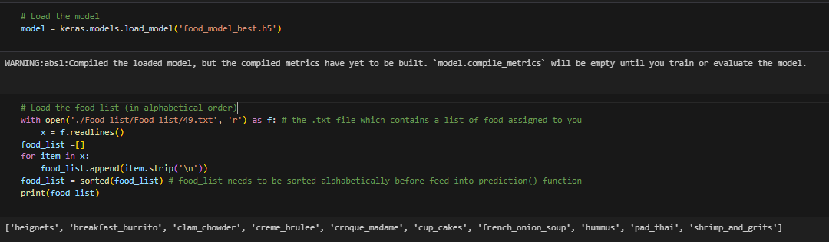

Real-world images are also gathered from the internet. Since the dataset provided is last updated in 2017, it would be necessary to utilise images after the updated date to ensure that the image used is not present in the dataset. This might cause unreliable results during predictions. The images are downloaded and placed in a folder for easy reading.

The image processing function processes the downloaded image into an array while the prediction function, predicts the food type based on the image array created. In the prediction function, the processed image is reshape to 150 by 150 by 3. The probability result is then shown. The highest probability is the result of the prediction. All the probabilities of each food type adds up to 1.

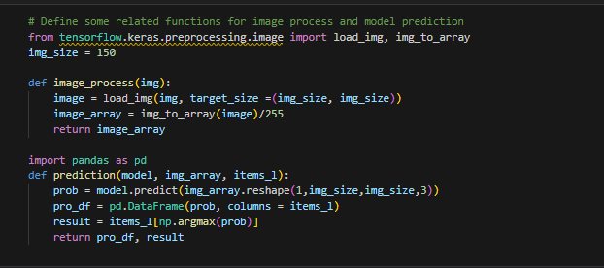

For each food type, 3 online images or personal images were used to ensure fairness during testing. The images are also different from each other with different backgrounds.

## Beignets

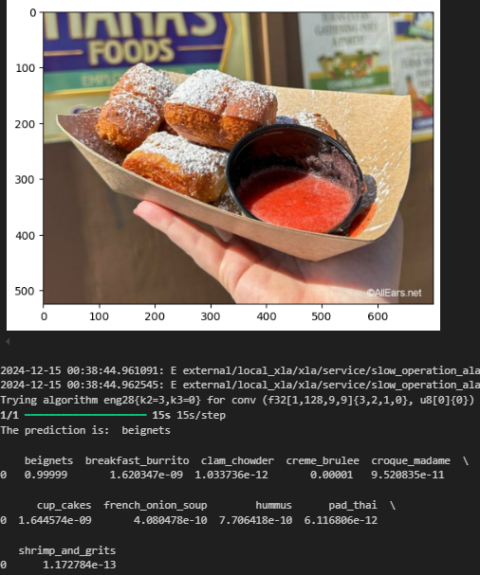 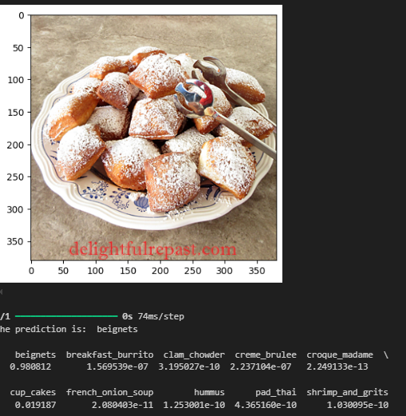 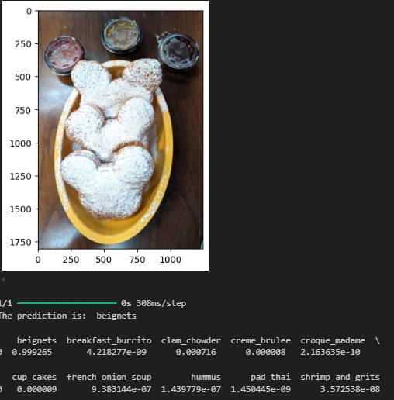

All the images used are predicted correctly as shown, with beignets having a higher probability than the other classes.

## Breakfast Burritos

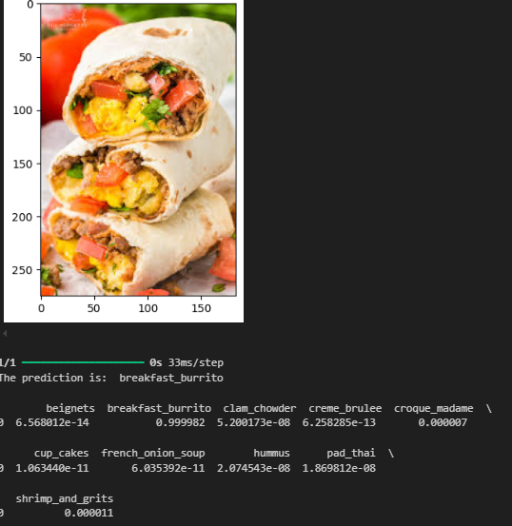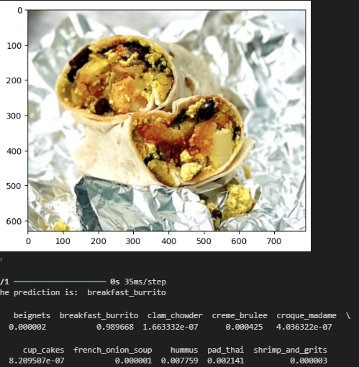 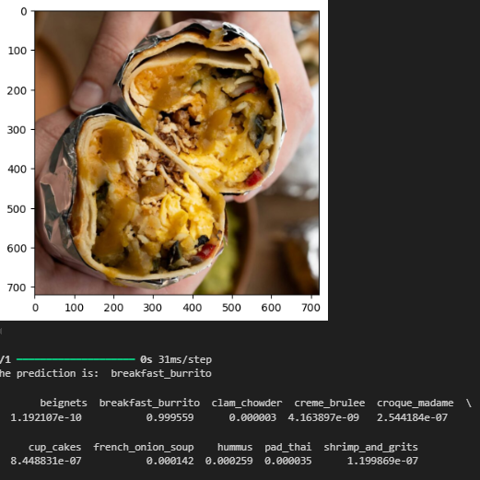

All the images used are predicted correctly as shown, with breakfast burrito having a higher probability than the other classes.

## Clam Chowder

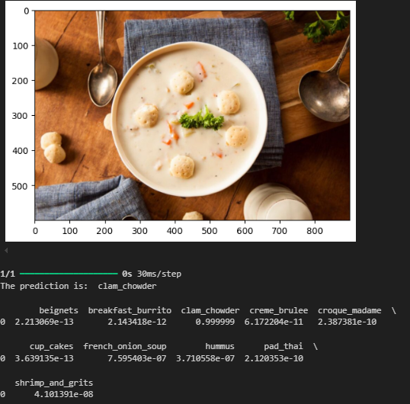 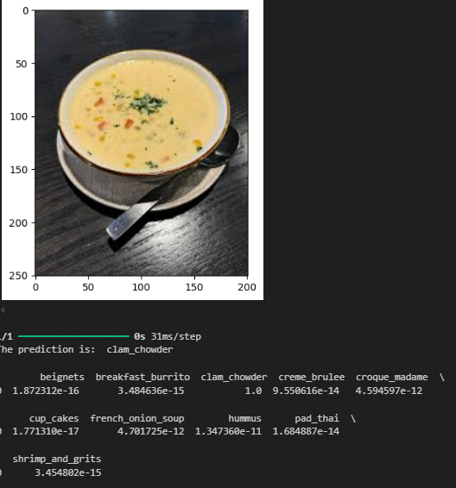 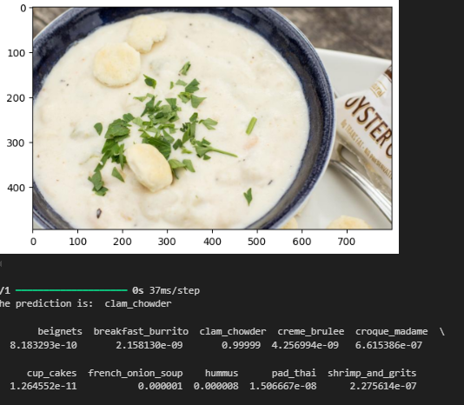

All the images used are predicted correctly as shown, with clam chowder having a higher probability than the other classes.

## Crème Brulee

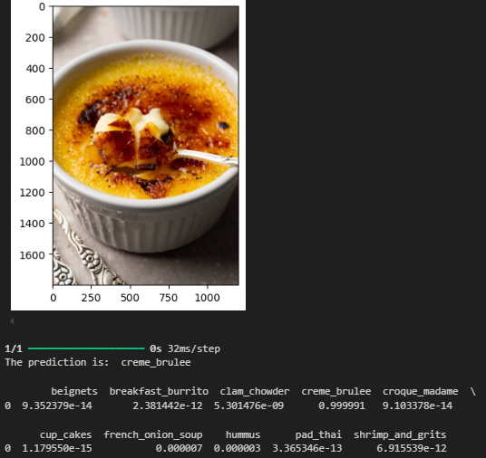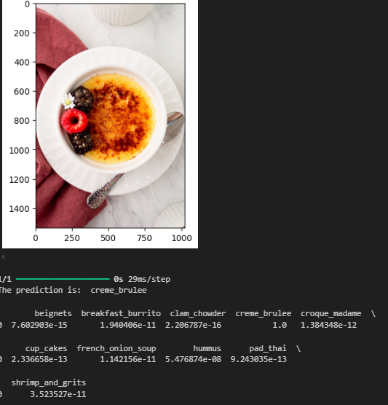 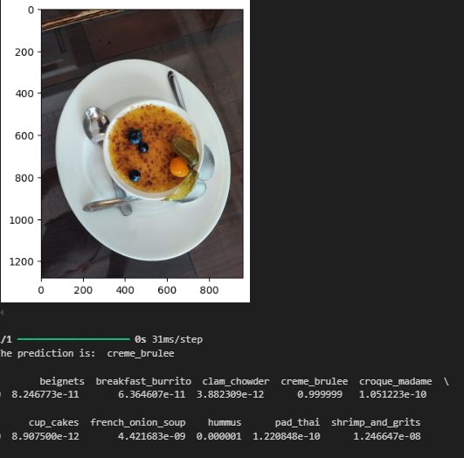

All the images used are predicted correctly as shown, with crème brulee having a higher probability than the other classes.

## Croque Madame

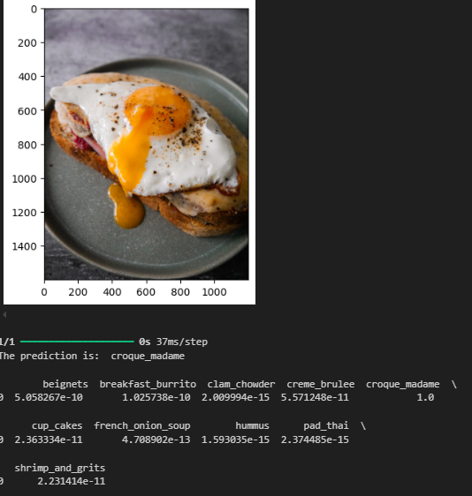 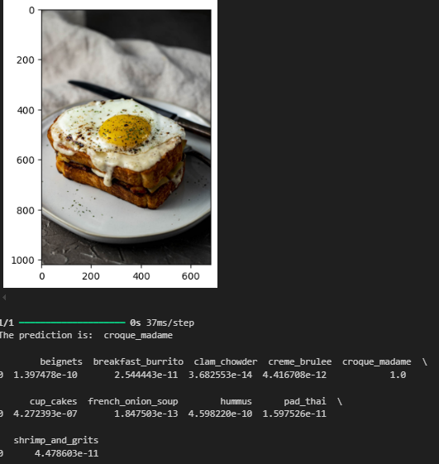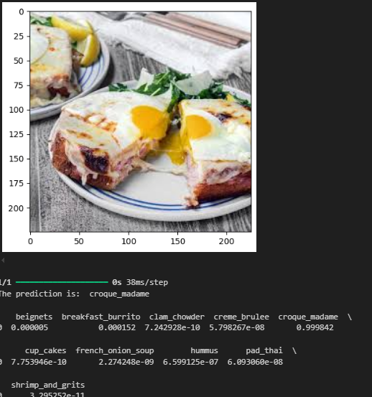

All the images used are predicted correctly as shown, with croque madame having a higher probability than the other classes.

## Cupcakes

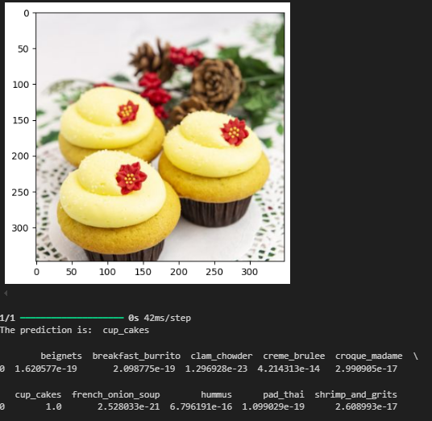 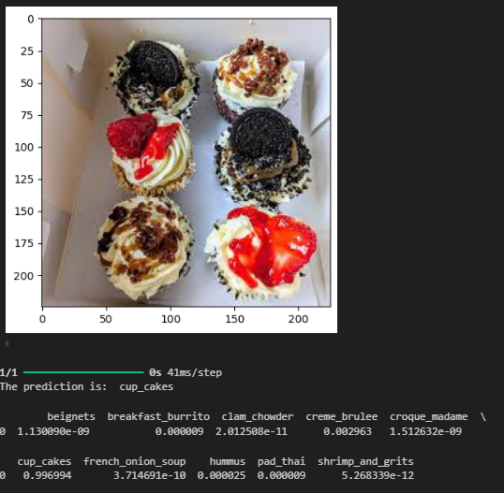 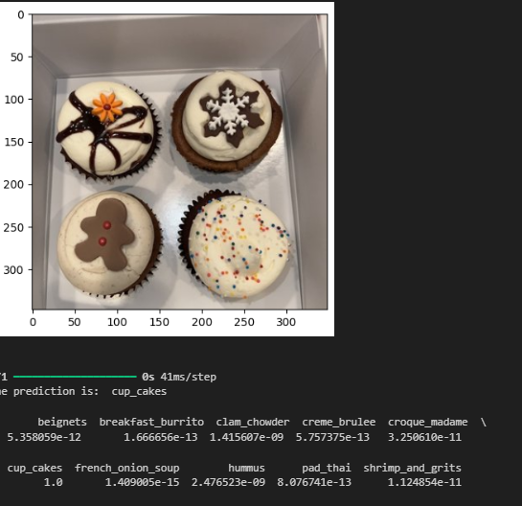

All the images used are predicted correctly as shown, with cupcakes having a higher probability than the other classes.

## French Onion Soup

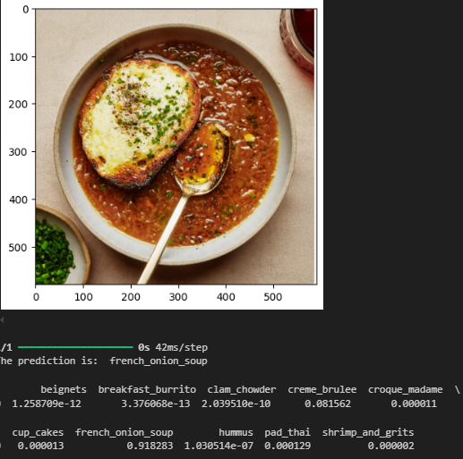 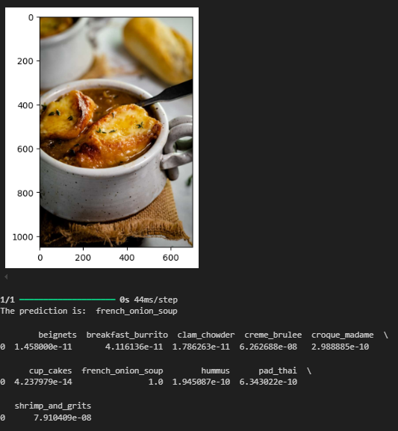 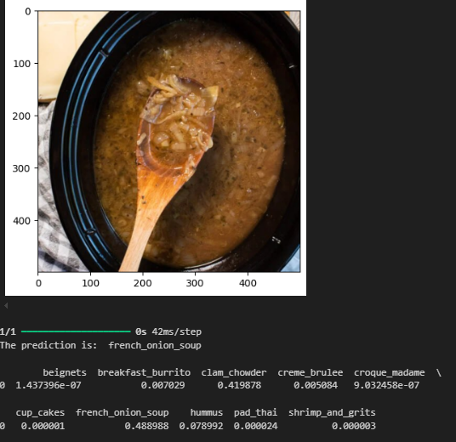

All the images used are predicted correctly as shown, with french onion soup having a higher probability than the other classes.

## Hummus

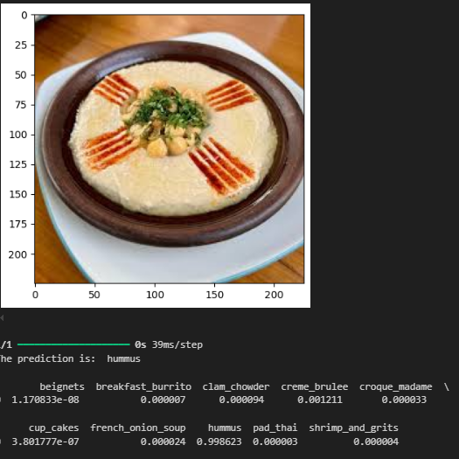 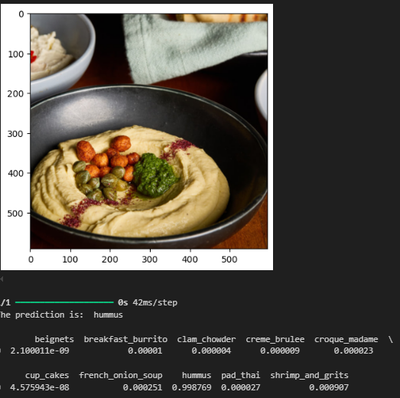 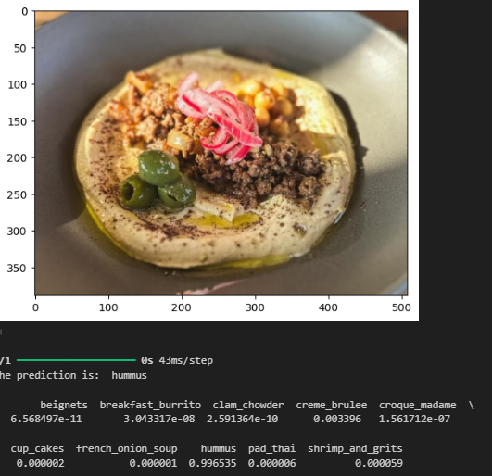

All the images used are predicted correctly as shown, with hummus having a higher probability than the other classes.

## Pad Thai

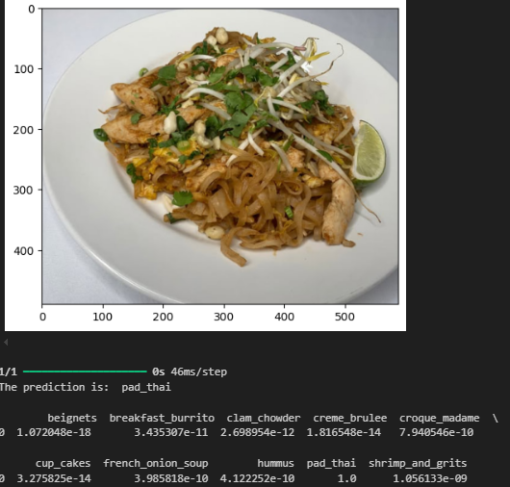 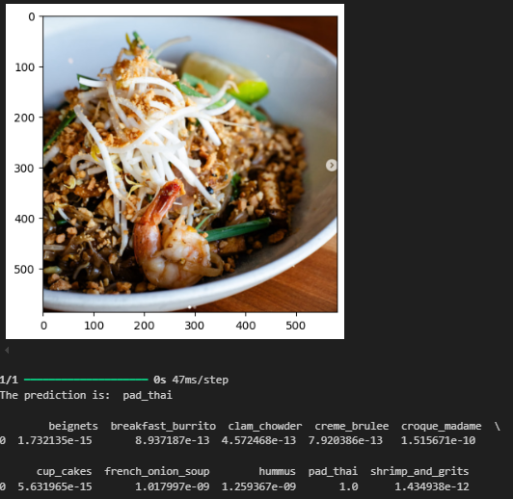 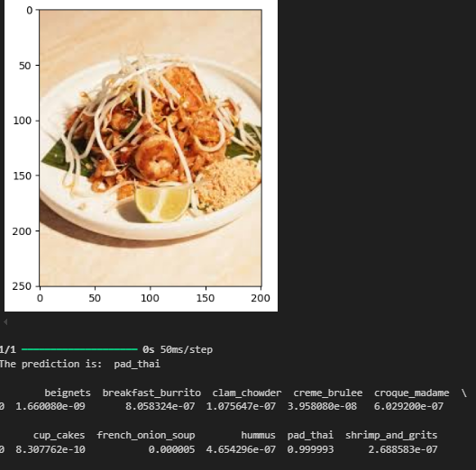

All the images used are predicted correctly as shown, with pad thai having a higher probability than the other classes.

## Shrimp and Grits

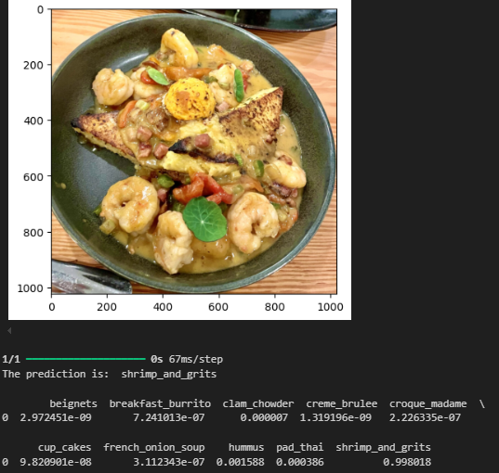 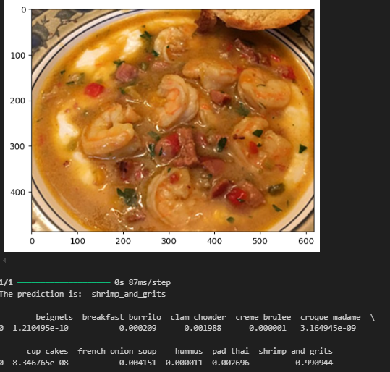 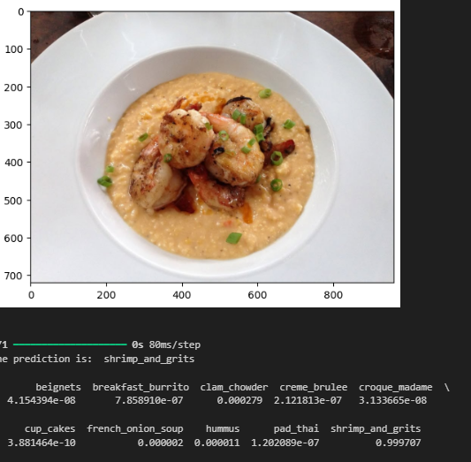

All the images used are predicted correctly as shown, with shrimp and grits having a higher probability than the other classes.

Overall, the model is able to predict all the images in the folder. This could mean that the model is accurate but further testing with more complex images can be conducted just to be sure. More complex images include eaten food and different lighting.

# Summary

The model demonstrates strong performance with:

* **Test Dataset:** 90% accuracy and a loss score of 0.49, indicating good predictive capability on unseen data.
* **Validation Dataset:** 89% accuracy and 0.4787 loss, which is consistent with the test performance, suggesting the model generalizes well.

Additionally, the model successfully predicts all downloaded images from the internet and images in the test folder, indicating robustness in controlled scenarios. However, further testing on more challenging images (e.g., partially eaten food, different lighting conditions) is necessary to ensure reliability in real-world applications.

## Further Improvements

Further improvements can be made to improve the scores and the processes when creating subsequent models. The improvements are as follows:

* The dataset diversity can be enhanced. More complex images that represent real-world variations can be collected or generated (e.g., different angles, lighting, or partially obscured objects) to evaluate and improve robustness.
* The models can be further fine-tuned by experimenting with hyperparameter tuning (e.g., learning rate, optimizer choice) especially for the pre-trained models.
* Edge cases can be classified. The models can be tested on edge cases (e.g., highly distorted or mixed images) to identify weaknesses and refine the model.
* Iterative and extensive testing can be conducted on real-world and augmented datasets to confirm generalization and identify areas for refinement.

# References

* ChatGPT. (n.d.). <https://chatgpt.com/c/675e31bf-151c-8007-8167-19fd0e4fe978>
* Team, K. (n.d.). Keras documentation: Layer weight regularizers. <https://keras.io/api/layers/regularizers/>
* Team, K. (n.d.). Keras documentation: Optimizers. <https://keras.io/api/optimizers/>
* Team, K. (n.d.). Keras documentation: Keras Applications. <https://keras.io/api/applications/>